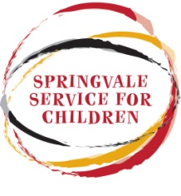
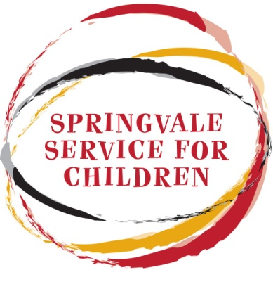
Springvale Service for Children Inc. - Toy Library

Incorporation Number A0052504L ABN 53 439 106 626

28 Lightwood Road, Springvale 3171
Ph: 8558 3800

Member Registration Form

Membership status | New |  | Renew |  | Date:
Last name: |  |  | First Name:
Partner last name: |  |  | First name:
Address: Postcode:
Telephone: |  |  | Mobile:
Email address (for newsletters and important messages only)

Child’s name |  |  | Birthday |  |  | Boy / Girl
Child’s name |  |  | Birthday |  |  | Boy / Girl
Child’s name |  |  | Birthday |  |  | Boy / Girl
(For groups): age range & number of children:
Membership type:

Family (10 toys per loan) Concession (10 toys per loan) FDC/group package (15 toys per loan)
My child currently attends Springvale Service for Children Early Learning Program

How did you hear about our Toy Library?

Health Nurse Toy Library member Greater Dandenong Council Book Library
Internet / website Brochure Passing by Other (please specify) ……………………………..
Declaration:
I hereby apply for membership of Springvale Service for Children (SSC) Inc. Toy Library, and agree to indemnify SSC., its members, staff and Board members against all loss or liability, howsoever caused, arising from borrowing by, or through me, any toys, games or other items. I agree to pay SSC Inc., fines and fees as per the current schedule, as agreed by the Board of Management. I understand that my membership is valid for 6months or 1 year from the date of joining.
I agree to return all toys and other items borrowed by the due date in a clean condition and will report any damage to staff.
I understand that membership is not transferable and is non-refundable.

Signature: Date:

Staff Use Only
Staff: |  | Date: |  | Number: |  |  | Card made:

Obligations of being a member:
- Members must provide Springvale Service for Children with their current address, phone number.
- Members take full responsibility of the toys that they borrow and that all toys are returned.
- Toys must be looked after when they are taken home.
- All toys should be cleaned thoroughly when returned.
- Any damaged to the toys must be reported to the staff of the toy library. If the damage is caused by misuse then a charge may be incurred. Normal wear and tear is anticipated
- A toy may be reserved at no charge and when available will be set aside for one week. You will be contacted by phone when the toy is available
- All parents and carers attending the toy library during opening hours are responsible for the children in their care.
On behalf of the members of the Springvale Service for Children Toy Library we would like to thank you for your consideration and welcome you to our service.

